Forsyth County Cloverbud 4-H Project Record Form
(5-7 Year Olds)

SECTION 1: Personal Information

County You Participate In 4-H: ______________ Program Year: _______

4-H Project Record Category in which you are entering: _________________________________

Number of Years in 4-H: _____

Name: __________ __________ __________ Male Female
(first) (middle) (last)

Name you want used in publicity: ______________________________________
(please print)

Home Mailing Address: ___________________________________________________

City: ______________________ State: ________ Zip Code: __________

Primary Telephone Number (include area code): ______________________________________

Date and Year of Birth: __________ Age as of January 1: __________
(age as of Jan. 1 for the project reporting year)
Names of parents or guardians: _______________________________________________

Name of your 4-H club or group: ______________________________________________

Name of School: __________________ Grade in School: __________________

I have reviewed this report and believe it to be correct:

___________________________________ _______________________________________
Parent(s) or Helper Signatures Date

___________________________________ _______________________________________
4-H Leader Signature Date

SECTION 2
My 4-H Story
(Place your 4-H Story behind this page)
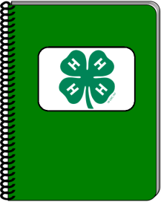

Tell us your 4-H story! Here are some things you COULD include in your story:

Tell us about yourself and your family. Include what you did in 4-H this year. Be sure to write at least one sentence on each project you completed. What did you enjoy most this year? What did you learn about? What special events did you get to attend? Were you ever a helper this year? Try to make your story fun for the reader. You might include something funny that happened to you. You may dictate your story to your project helper.

Hello. My name is ____________________________________________. I am _____ years old and have been a member of the _______________ 4-H club for ___ years. I live with __________________________ and have (tell about your pets)___________________________. (What do you enjoy learning about or doing other than 4-H?Did you learn to ride a bike this year?). I enjoy ____________________
_____________________________________________________________________.
With 4-H, I enjoy _________________________________. With my club, I have (what projects?) ________________________________________________________
______________________________________________________________________
______________________________________________________________________
______________________________________________________________________

My favorite community service activity this year was _______________________. (Give a couple reasons why it was your favorite). ______________________________________________________________________
______________________________________________________________________
Other activities I’ve enjoyed in 4-H this year are… (contests, presentations, summer adventures, leading a project/activity, talent show, …)

Program Year:_____
SECTION 3
4-H Project Focus

(Name of 4-H Project)

List the specific things you learned and did in this project area during the past year (Jan-Dec.).List new things you learned. Use numbers to show how much you did, how many items you made, how much money you earned or saved, etc. List only things in this particular project area, not everything you did in 4-H. (You can talk about everything in your story and scrapbook sections)

What did you do in this project this year and when? | When?
I learned where the leg is on my sheep | April 3
Went to a Summer Adventure | July 7

2. What was your favorite part of this project?

Program Year:_____
SECTION 4
4-H Photos and Supporting Materials
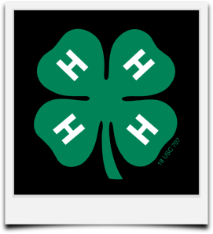
The majority of this section should be about this specific project.
Also, include a portion of your other 4-H projects and activities.
There is a six-page limit.
This can include pictures (with captions), drawings, news clippings, letters, certificates, poems, or anything else you have collected or done in 4-H this year.
The use of clear non-glare protective sheets is optional.

Use your creativity in this section to tell special things about your project.

(Attach pages here)

SECTION 5 Program Year:_____
4-H Goal Setting

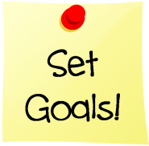
What would you like to do next year in 4-H? You might want to go fishing with your club or learn how to launch rockets. Perhaps, you’d like to clean up your neighborhood or learn to make pizza. The possibilities are endless.

This page is designed for you to record what you want to do and learn next year. The things you plan to learn and do are called “goals”. Goals can be completed alone or with your friends. To begin, list the things you’d like to learn or do. List things like participating in specific projects, going to 4-H camp, modeling in a fashion show and serving as a 4-H helper for your leader.

You might also think of new goals during this year. If you do, just add them to your goals along with the month you think you’ll do them.

MY 4-H PLAN
What things do you want to learn or do? Month to do them
Examples:
Go to 4-H Camp July
Make a lamp March
Be in the 4-H Talent Show When it’s scheduled
Make and shoot a rocket Spring
Learn where the leg is on my sheep April
Learn how to maintain my bicycle August

Record your plans below: (you can add another page if you’d like)

